Neeraj Appari T073

Wireless Sensor Networks and Mobile Communication Practical 10

Aim: Create a network using smartphone, wireless router WRT300N, Hub-pt, 1841 Router, central office-server, Cell-Tower. Simulate connection between them

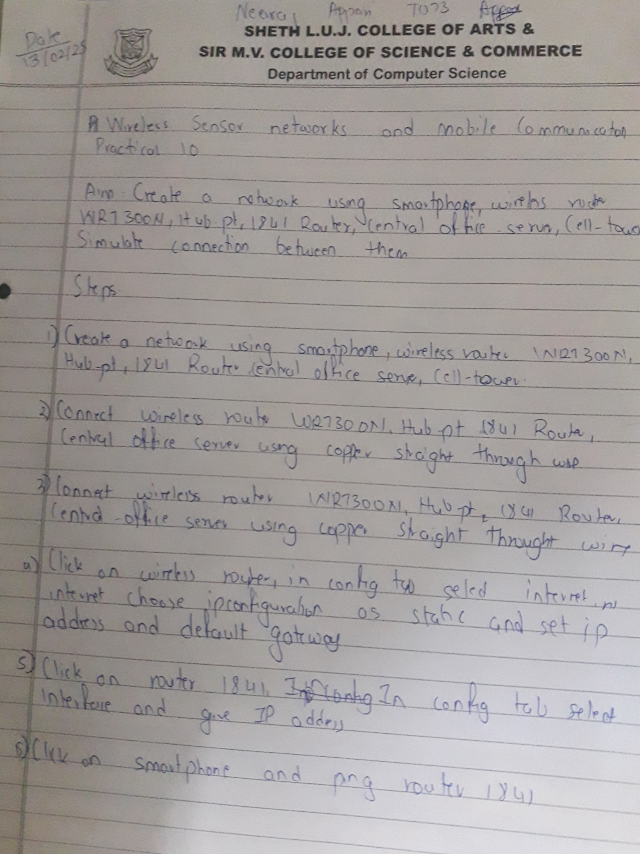

Steps-

Connect cell tower and central office server using coaxial cable. 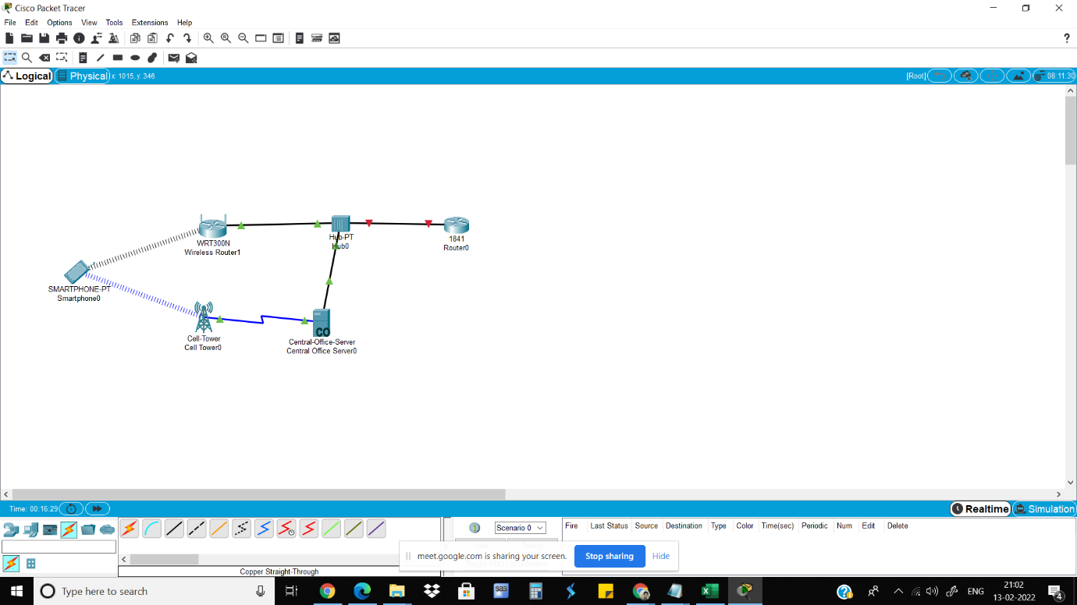 Connect wireless router WRT300N, Hub-pt, 1841 Router, central-office-server using copper

straight through wire.

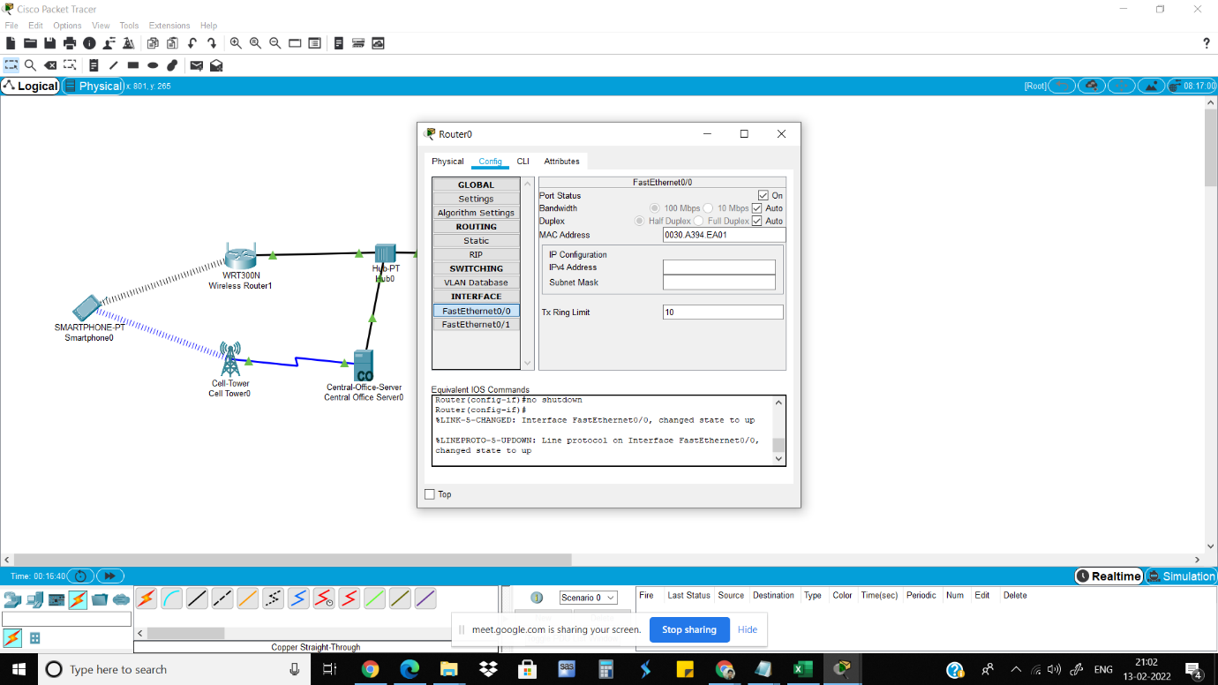

Click on wireless router.in config tab select internet.in internet choose ip configuration as static

and set IP address and default gateway

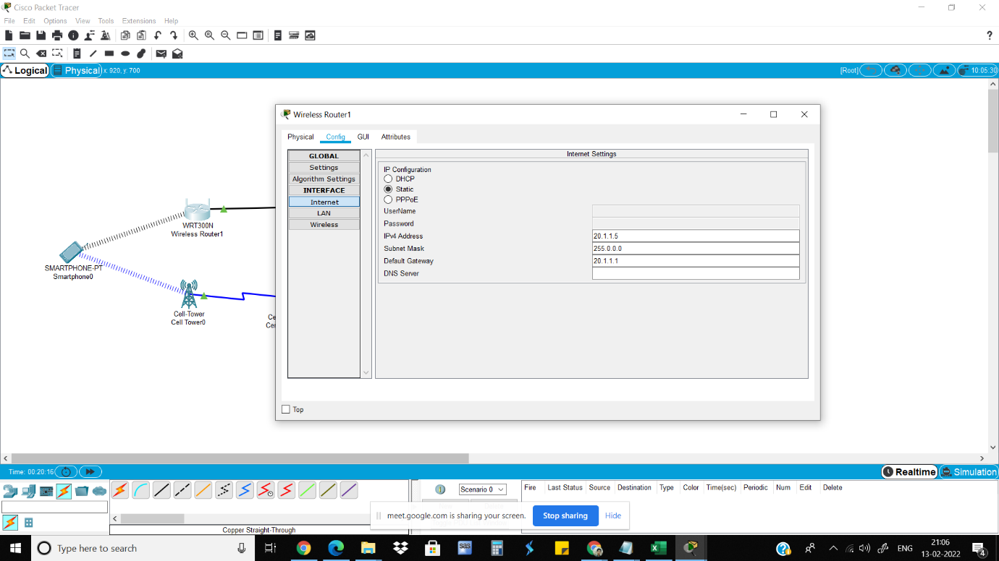

Click on router 1841. In config tab select interface and give IP address

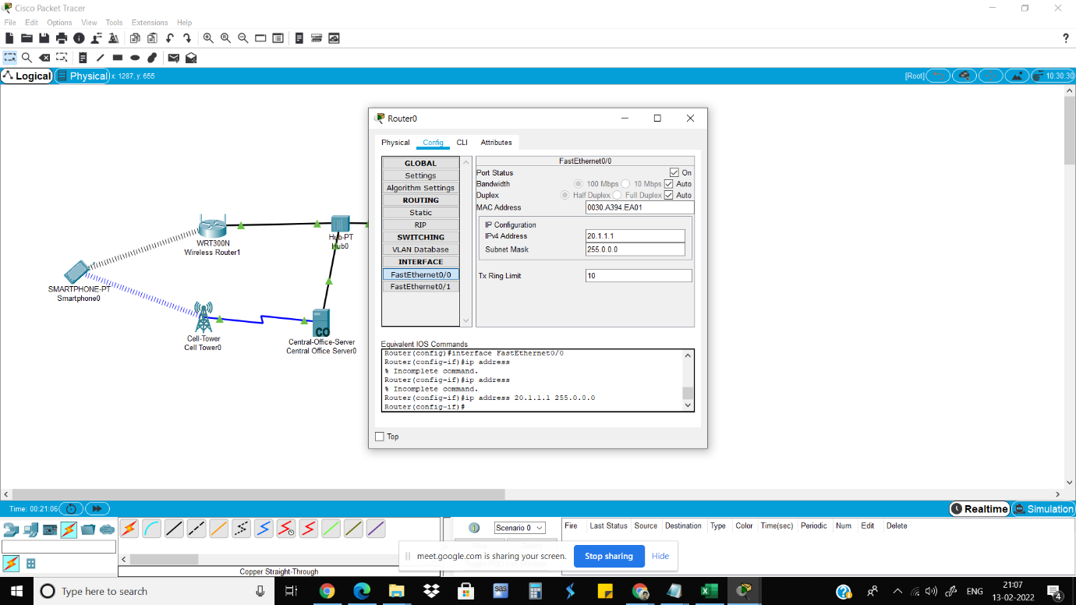

Click on smartphone and ping router1841

